Mandatory Exercise 1

Numeriske metoder

Table of Contents

Exercise 1 2

Problem I 2

Problem II 2

Problem III 2

Problem IV 2

Problem V 2

Problem VI 3

Full Terminal Solution 4

# Exercise 1

## Problem I

Find the Singular Value Decomposition $A=UWV^{T}$. State the diagonal elements in W.

Code main.cpp in zip.file.



## Problem II

Use the Singular Value Decomposition to compute the solution x to Ax = b. State the

solution x. Code main.cpp in zip.file.



## Problem III

State an estimate of the accuracy on the solution x. State an explanation of how you computed the accuracy. Code main.cpp in zip.file.

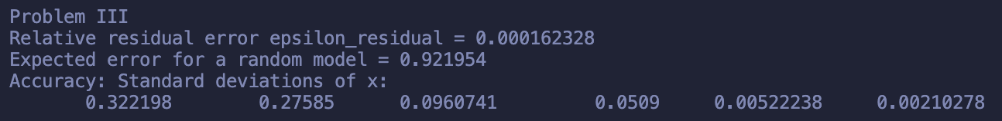

The relative residual error measures how well the solution fits the data, while the standard deviations indicate the precision of each component of x.

The expected error for a random model provides a benchmark for comparison.

## Problem IV

Compute and state the residual vector $r≡Ax-b$. Code main.cpp in zip.file.



## Problem V

Compute the new $σ_{i}$'s and then the new design matrix A and new right hand side b. State

[A]0,0 and [b]6. Code main.cpp in zip.file.

## Problem VI

Compute and use the Singular Value Decomposition to compute the solution x to Ax = b

with the new design matrix and new right-hand side. State the solution x.



## Full Terminal Solution

